3D Printing. Materials.

- Video. 3D Printing is changing the world.

Word | Definition | Example
To contaminate  /kənˈtæmɪneɪt/ | To make something impure or unclean by adding a harmful or unwanted substance. | The laboratory technician accidentally contaminated the sample, rendering it unusable for the experiment.
To fabricate  /ˈfæbrɪkeɪt/ | To create or construct something, often using various materials or components. | The company uses advanced 3D printing technology to fabricate customized prosthetic limbs for amputees.
Heart valve  /hɑːt vælv/ | A structure in the heart that regulates the flow of blood. | The surgeon replaced a damaged heart valve with a prosthetic one to improve the patient's cardiac function.
Fluid  /ˈfluː.ɪd/ | A substance that can flow and take the shape of its container. | The hydraulic system uses fluid to transmit power and control the movement of machinery.
To force sth back and forth /fɔːθ/ | To exert pressure or apply a repetitive motion to make something move in opposite directions. | The piston in the engine forces air back and forth, converting thermal energy into mechanical energy.
Carotid artery  /kəˌrɒt.ɪd ˈɑː.tər.i/ | One of the major blood vessels in the neck that supplies blood to the brain, face, and head. | The surgeon carefully repaired the damaged carotid artery to restore blood flow to the brain.
A trinket  /ˈtrɪŋ.kɪt/ | A small, decorative item or piece of jewelry that is often considered to have little value. | She bought a beautiful trinket as a souvenir from her trip to Paris.
To sew sth on  /səʊ/ | To attach or fasten something using for example a needle and thread. | The tailor skillfully sewed the buttons on the shirt to ensure they were securely attached.
(in)accessible  /əkˈses.ə.bəl/ | (Not) able to be reached, entered, or obtained. | The website offers a mobile-friendly version to ensure that the content is accessible on various devices.
Pneumatic distribution  /njuːˈmæt.ɪk ˌdɪs.trɪˈbjuː.ʃən/ | The use of compressed air or gas to power or control the movement of objects or fluids. | The pneumatic distribution system efficiently transports packages through a network of tubes in large facilities.
Housing  /ˈhaʊ.zɪŋ/ | A structure or container that provides protection or support for something. | The hard drive is enclosed in a protective housing to shield it from external damage.
Implication  /ˌɪm.plɪˈkeɪ.ʃən/ | The logical consequence or result of an action or statement. | The introduction of self-driving cars has significant implications for the future of transportation and urban planning.
Supply chain  /səˈplaɪ ˌtʃeɪn/ | The network of organizations and activitieщs involved in the production and distribution of a product or service. | 3D printing can disrupt traditional supply chains by allowing on-demand production and reducing the need for extensive inventory.
Ground up tools  /ɡraʊnd ʌp tuːlz/ | Tools or equipment that are built or designed from scratch, starting with the basic components. | The engineers developed ground-up tools specifically for 3D printing, optimizing them for the unique requirements of the technology.
To subject sth to sth  /səbˈdʒekt/ | To expose or put something through a particular process or condition. | The newly printed part was subjected to rigorous testing to ensure its strength and durability.
To upend  /ʌpˈend/ | To completely change or disrupt an existing situation or system. | 3D printing has the potential to upend traditional manufacturing methods by enabling decentralized production and customization.
Material science chamber  //məˈtɪə.ri.əl ˈsaɪ.əns ˈtʃeɪm.bər / | A controlled environment where materials used in 3D printing can be analyzed, tested, or developed. | Researchers are studying new materials in the material science chamber to improve the performance and capabilities of 3D-printed objects.
To morph /mɔːf/ | To change or transform gradually or smoothly from one state or form to another. | The shape-shifting toy was created using 3D printing technology, allowing it to morph into different configurations.
Self-assembly  /ˌself.əˈsem.bli/ | The process by which parts or components come together to form a complete object without external intervention. | The 3D-printed furniture pieces were designed for self-assembly, allowing users to easily put them together without additional tools.
Cubic lattice structure /ˈkjuː.bɪk ˈlæt.ɪs// | A three-dimensional framework or pattern consisting of interconnected cubic units. | The lattice structure of the 3D-printed object provided it with high strength-to-weight ratio and structural integrity.
To converge /kənˈvɜːdʒ/ | To come together or meet at a common point or in a shared direction. | The fields of 3D printing and robotics are converging, leading to the development of advanced robotic additive manufacturing systems.
In pursuit of  /pəˈsjuːt/ | Striving or working towards achieving something. | Researchers continue to explore new materials and techniques in pursuit of faster, more precise, and versatile 3D printing methods.
Filament  /ˈfɪl.ə.mənt/ | The material, typically in the form of a thin thread or wire, used as the raw material for 3D printing. | The 3D printer extrudes filament, layer by layer, to build the object according to the digital design.
Loop life cycle  /luːp ˈlaɪf ˌsaɪ.kəl// | The continuous process of designing, producing, using, and recycling materials or products in a closed loop to minimize waste and maximize sustainability. | 3D printing can support a circular economy by enabling a loop life cycle, with the ability to recycle and reuse materials in the printing process.
To warp /wɔːp/ | To deform or distort due to heat, pressure, or other factors. | If the 3D-printed object is not properly cooled, it may warp or lose its intended shape.
Enabling technology  /ɪˈneɪblɪŋ tekˈnɒl.ə.dʒi// | A technology or innovation that provides a foundation or support for the development or advancement of other technologies or processes. | 3D printing is considered an enabling technology because it opens up new possibilities for design, customization, and rapid prototyping.

- Video: 3D printing a fast-morphing smart materials
- Video: New 3D printer makes multi-material robots
- Jigsaw Reading: 3D Printing
Morphing n.  /ˈmɔːfɪŋ/ | The process of smoothly transforming one image or shape into another, often used in digital graphics and animation to create seamless transitions. | The artist spent hours morphing the original sketch into a vibrant digital illustration, showcasing the evolution of her creative vision.
Polarity n.  /pəˈlærɪtɪ/ | The condition of having two opposite poles or tendencies, often referring to the distribution of electrical charge in chemistry, magnetism, or the existence of contrasting opinions or characteristics. | The increasing polarity between the two political parties has made it difficult to reach a consensus on important issues.
Magnetise v.  /ˈmægnɪtaɪz/ | To make an object magnetic or to impart the properties of a magnet to it. | When exposed to a strong magnetic field, the iron filings began to magnetise, aligning themselves along the field lines.
Resolution n.  /rezəˈluːʃn/ | The smallest change in a quantity that an instrument can detect, indicating the precision of the measurement. | The resolution of the microscope allowed scientists to clearly distinguish between individual cells in the tissue sample, revealing details that were previously obscured.
Transform v.  /trænsˈfɔːm/ | To change in form, appearance, or structure; to convert or transmute something into a different state or condition. | In the process of photosynthesis, plants transform sunlight into chemical energy, allowing them to grow and thrive.
Remotely adv.  /rɪˈməʊtlɪ/ | From a distance; in a manner that is not physically connected or close. | Using remote sensing technology, scientists can monitor environmental changes in ecosystems that are located remotely from their research facilities.
Magnetic field n.  /mægˈnetɪk fiːld/ | A vector field that describes the magnetic influence on moving electric charges, electric currents, and magnetic materials. | The Earth’s magnetic field protects the planet from solar radiation by deflecting charged particles away from its surface.
Polarity n.  /pəˈlærɪtɪ/ | The distribution of electrical charge within a molecule, resulting in the formation of distinct positive and negative ends or poles. | The polarity of water molecules allows them to dissolve many ionic and polar substances, making water an excellent solvent in biological systems.
Contract v.  /kɒnt`rækt/ | To decrease in size, volume, or extent, often as a result of external forces or changes in temperature. | As the temperature dropped, the metal began to contract, causing the joints of the structure to fit more tightly together.
Deform v.  dɪˈfɔːm/ | To change the shape or structure of something, especially by applying pressure or stress, resulting in a misshapen or distorted form. | When subjected to extreme heat and pressure, the rock began to deform, altering its original structure and creating new mineral formations.
Appendage n.  /əˈpendɪʤ/ | A part or organ that is attached to the main body of an organism, such as limbs, fins, or antennae, which serve specific functions. | The insect's long antennae serve as sensory appendages, allowing it to detect changes in its environment.
Precision n.  /prɪˈsɪʒən/ | The degree to which repeated measurements under unchanged conditions show the same results. The closeness of two or more measurements to each other, regardless of whether they are close to the true value. | The precision of the laboratory instruments was crucial for obtaining reliable data, as even slight variations in measurements could lead to significant differences in the experimental outcomes.
Millipede n.  /ˈmɪlɪpiːd/ | An arthropod belonging to the class Diplopoda, characterized by having two pairs of jointed legs on most of its body segments. | In the damp forest floor, the millipede slowly crawled over fallen leaves, playing a crucial role in the ecosystem by breaking down dead plant material.
Nozzle n.  /nɒzl/ | A device designed to control the direction or characteristics of a fluid flow, such as liquid or gas, as it exits or enters an enclosed chamber. | In rocket propulsion, the nozzle is crucial for directing the high-speed exhaust gases, allowing the rocket to achieve thrust and maneuver in space.
Vacuum n.  /ˈvækjʊəm/ | A space that is devoid of matter, characterized by a pressure significantly lower than atmospheric pressure. | In the laboratory, researchers used a vacuum chamber to conduct experiments on the behavior of materials in conditions that closely mimic outer space, where the absence of air allows for unique phenomena to be observed.
Vat n.  /væt/ | ​a large container for holding liquids, especially in industrial processes | As a metal platform rises from a vat of liquid resin, it pulls an intricate white shape from the liquid — like a waxy creature emerging from a lagoon.
Resin n.  /ˈrezɪn/ | an artificial substance similar to resin, used in making plastics

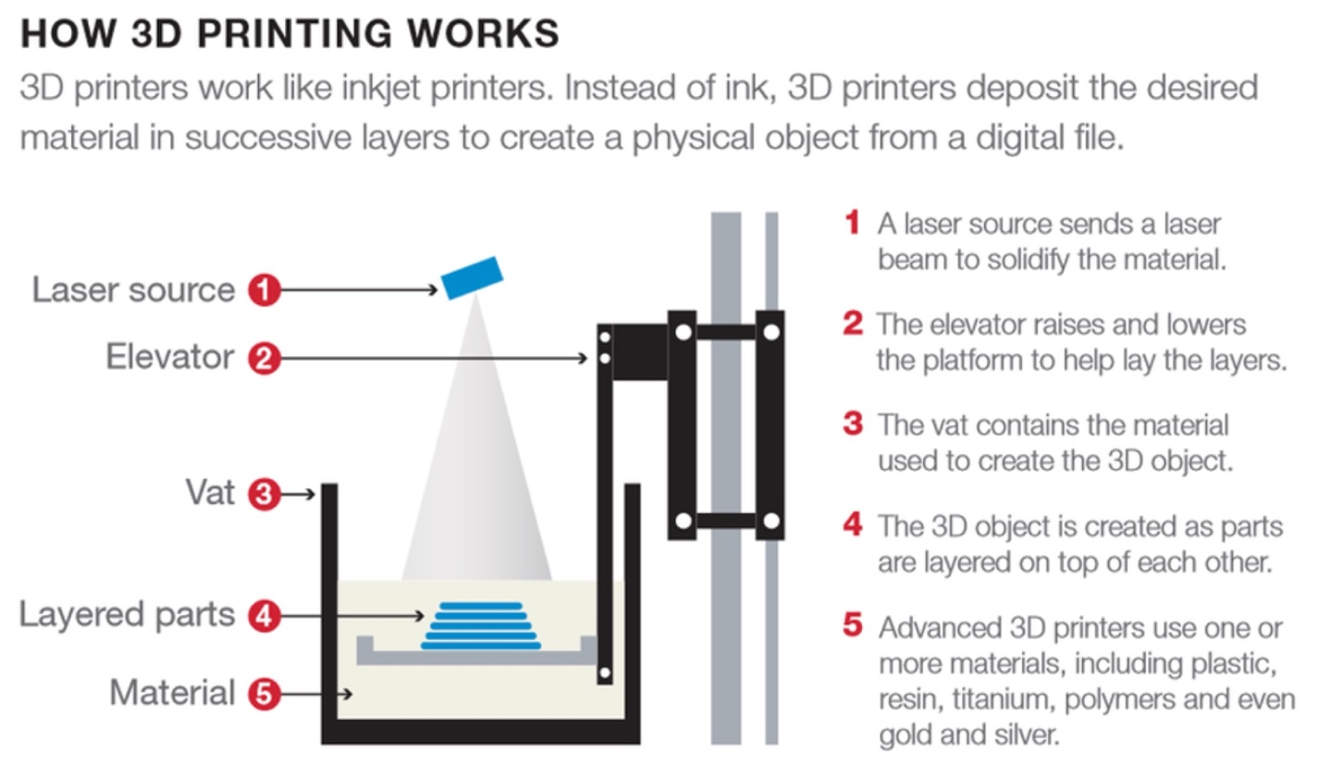

Technical Vocabulary: Materials and properties

Ceramic adj  /səˈræmɪk/ | made of clay that has been made permanently hard by heat | This textured ceramic vase is part of the Scratch collection of organically shaped bowls and vessels.
Ferrous adj  /ˈferəs/ | containing iron; connected with iron | ferrous and non-ferrous metals
Aliminium  /ˌæljəˈmɪniəm/ | a chemical element. Aluminium is a light, silver-grey metal used for making pans, etc. | aluminium saucepans/window frames
Cement n.  /sɪˈment/ | a grey powder made by burning clay and lime that sets hard when it is mixed with water. Cement is used in building to stick stones and bricks together and to make very hard surfaces. | Use a mixture of one part cement to four parts sand.
Copper n.  /ˈkɒpə(r)/ | a chemical element. Copper is a soft red-brown metal used for making electric wires, pipes and coins. | a copper mine
Zinc n.  /zɪŋk/ | a chemical element. Zinc is a blue-white metal that is mixed with copper to produce brass and is often used to cover other metals to prevent them from rusting. | This process is applied for all experiments with the various zinc concentrations.
Fibre n.  /ˈfaɪbə(r)/ | a material such as cloth or rope that is made from a mass of natural or artificial threads | nylon and other man-made fibres
Alloy n.  /ˈælɔɪ/ | a metal that is formed by mixing two types of metal together, or by mixing metal with another substance | Brass is an alloy of copper and zinc.
Brass n.  /brɑːs/ | a bright yellow metal made by mixing copper and zinc; objects made of brass | solid brass fittings/door handles
Polymer n.  /ˈpɒlɪmə(r)/ | a substance consisting of large molecules (= groups of atoms) that are made from combinations of small simple molecules | Many polymers, such as nylon, are artificial.
Steel n.  /stiːl/ | a strong, hard metal that is made of a mixture of iron and carbon | the iron and steel industry
Nylon n.  /ˈnaɪlɒn/ | a very strong artificial material, used for making clothes, rope, brushes, etc. | This material is 45 per cent nylon.
Silicon n.  /ˈsɪlɪkən/ | a chemical element. Silicon exists as a grey solid or as a brown powder and is found in rocks and sand. It is used in making glass and transistors. | silicon computer processors
Synthetic adj  /sɪnˈθetɪk/ | artificial; made by combining chemical substances rather than being produced naturally by plants or animals | Sythentic fabrics
Composite adj  /ˈkɒmpəzɪt/ | ​made of different parts or materials | Scientists have put together a composite picture of what the earth's crust is like.
Composite n.  /ˈkɒmpəzɪt/ | a mixture of different materials used for building, making objects, etc. | The balls are now made of plastic composite instead of leather.
Malleability n.  /ˌmæliəˈbɪləti/  Malleable adj | the ability to be hit or pressed into different shapes easily without breaking or cracking (= starting to split) | The softness and malleability of gold makes it perfect for making jewellery.
Absorbency n.  /əbˈzɔːbənsi/  Absorbent adj | the quality of being able to take in something easily, especially liquid | Cotton has high absorbency.
Density n.  /ˈdensəti/  Dense adj | how thick a solid, liquid or gas is, measured by its mass per unit of volume | the density of a gas
Fusibility n.  /ˌfjuːzəˈbɪlɪti/  Fusible adj | the quality of being fusible or convertible from a solid to a liquid state by heat | Subsequently, due to a leaking fusible plug, it was taken out of service.
Conductivity n.  /ˌkɒndʌkˈtɪvəti/  Conductive adj | the quality of being able to conduct electricity, heat, etc. | Aluminium is a conductive metal.
Compatibility n.  /kəmpætəˈbɪlɪtɪ/ | The ability of substances, systems, or components to coexist or function together without adverse reactions or failures. | When designing medical devices, engineers must ensure the compatibility of materials with human tissues to prevent adverse reactions during implantation.
Flexibility n.  /fleksəˈbɪlɪtɪ/  Flexible adj.  /ˈfleksəbl/ | The ability of a material or system to deform elastically when a force is applied and return to its original shape when the force is removed. | The flexibility of the rubber material allowed it to absorb shocks effectively, making it ideal for use in protective gear and cushioning applications.

